Reading 3

*Lonneke Lammers*

*10371672*

Read the following articles and answer these questions: Colin Ware, Chapter 1 and Chapter 2.

Question  
Ware describes bottom up and top down processing of visual information in the brain. Give a concrete and detailed example of how bottom up processing is influenced by top down processing, leading to a potentially wrong interpretation of “reality” by the viewer. Your example can include a screenshot, photo, or web site URL to refer to the scene that is being viewed.

Answer  
Ware describes that visual thinking consists of different stages and series of acts of attention. Acts of attention are eye-movements and tuning our pattern-finding circuits, which are called visual queries. He says that when you interact with an information display we are usually trying to solve some kind of cognitive problem.

But we are not always thinking visually. It depends on the external environment and de awareness of the how structured and directed our seeing process is. Furder he says that perception is determined by two kinds of processes: bottom-up and top-down, where bottom-up is driven by the visual information in the pattern of light falling on the retina, and top-down is driven by the demands of attention which in turn are determined by the needs of the tasks. An example of bottom-up is that you are looking to something, like a laptop, you see the shapes, see the keyboard, and then conclude it’s a laptop. An example of top-down is that you are looking for your laptop, walk to your room and start searching for the particular shape of your laptop to find this thing.

Now, how is bottom-up processing influenced by top-down processing, leading to a potentially wrong interpretation of ‘reality’ by the viewer? For this example I picked the following example of optical illusion from the internet.

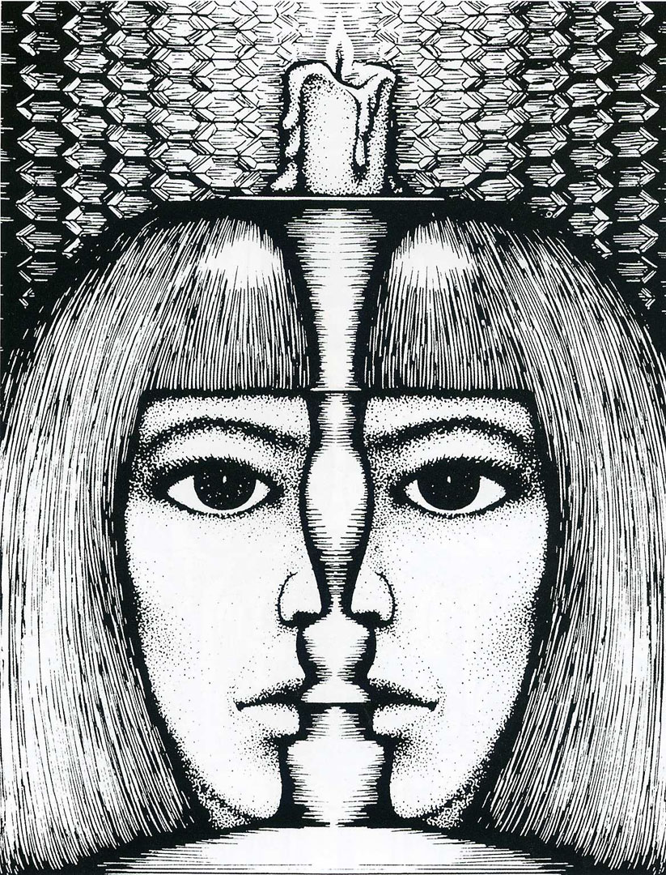When you are looking at this picture, you think you look to a front face behind a candler. But because you know this image is an optical illusion image, your are also searching for something else, which you can compare with top-down processing. When you look at this image on the top-down processing way, you can see two faces from the side who are looking to each other. You can ask yourself here what the real image is. Is there a real one-right image, or are there two images? I think the viewer can’t be sure anymore what is the ‘reality’. I can’t make one conclusion about what this image shows the watcher.

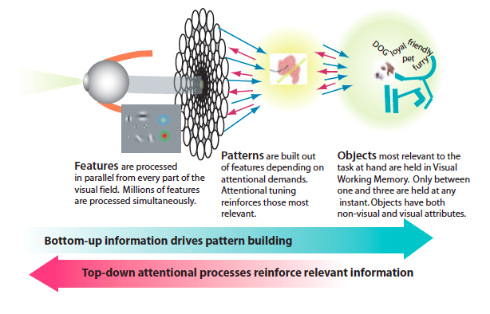

Blz. 10:

In the bottom-up view, information is successively selected and filtered so that meaningless low-level features in the fi rst stage form into patterns in

the second stage, and meaningful objects in the third stage.

Blz. 12:

We use the word attention to describe top-down processes. Top-down

processes are driven by the need to accomplish some goal. Th is might be

an action, such as reaching out and grasping a teacup or exiting a room.

It might be a cognitive goal, such as understanding an idea expressed in

a diagram. Th ere is a constant linking and re-linking of diff erent visual

information with diff erent kinds of nonvisual information. Th ere is also

a constant priming of action plans (so that if we have to act, we are ready)

and action plans that are being executed. Th is linking and re-linking is

the essence of high-level attention, but it also has implications for other

lower-level processes.